Supporting information

Appendix S1 — See Excel spreadsheet for the database of occurrence records of Mytilus galloprovincialis in southern Africa.

Appendix S2

Fig. S2. Average (global) wavelet power spectrum of fluctuations in the known range of Mytilus galloprovincialis on rocky shores across southern Africa based on sampled sites within a given year. Significant wavelet power shown in red.

Appendix S3

Fig. S3. Size-frequency distributions of mussel shell lengths of 12 populations of Mytilus galloprovincialis in South Africa.

Appendix S4

Fig. S4. Proportion of mussels, Mytilus galloprovincialis, in small range-edge populations (data pooled from 8 populations) and larger non-range-edge populations towards the range center (4 populations) in South Africa as a function of level of endolithic infestation on mussel shells (level categories: 0, > 0 to 25, > 25 to 50, > 50 to 75, > 75 to < 100, and 100%). Range-edge = populations from Tenza Beach, Mazeppa Bay, Seagulls, Kei Mouth, Morgans Bay, Haga Haga, Cintsa West, and Glen Gariff. Non-range-edge = populations from Kidd’s Beach, Old Woman’s River, Nature’s Valley, and Mosselbaai.

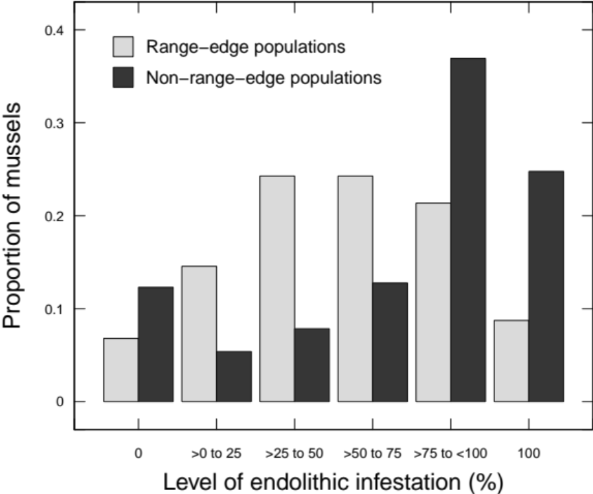
Appendix S5

Fig. S5. Harvest of mussels and limpets during low tide in the Transkei region of South Africa: (a) limpets collected from Presley Bay in October 2019; (b) mix of mussels and limpets from Coffee Bay in March 2020; (c) mix of mussels and limpets from Hole-in-the-Wall in March 2020; (d) limpets collected from Folokwe in March 2020. Photo credit: KCKM.

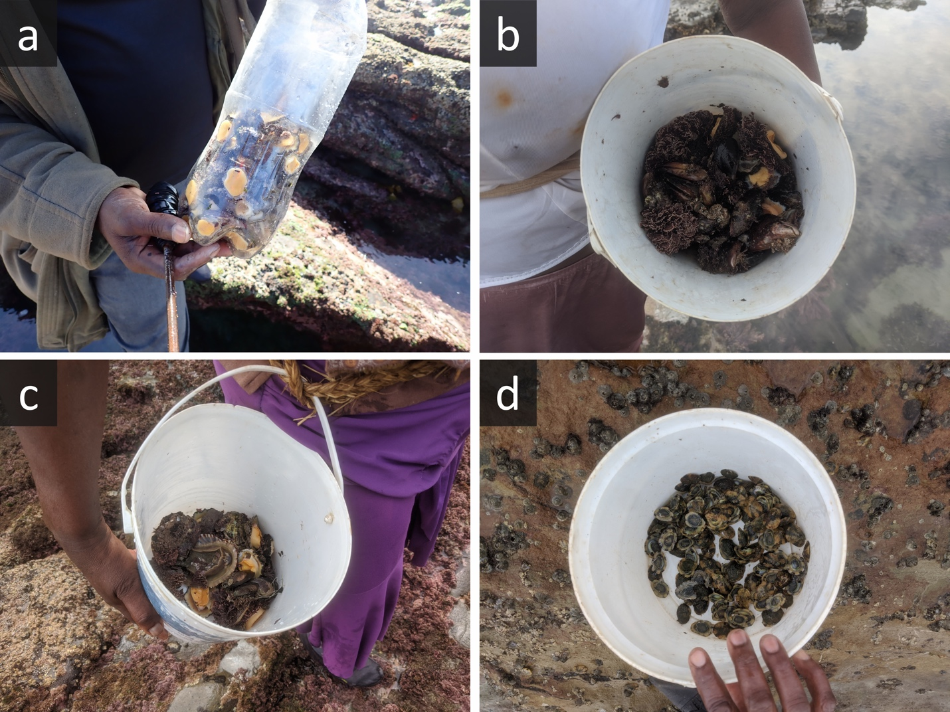

Appendix S6

Fig. S6. In situ observations of Mytilus galloprovincialis in on rocky shores of the Transkei region in South Africa: (a) Tenza Beach in January 2020; (b) Mazeppa Bay in January 2020; (c) Seagulls in March 2020; (d) Kei Mouth in January 2020. Photo credit: (a, b, d) KCKM and (c) MNCG.

